ToDo List.

**Requirement**:

Build a ToDo application with option to add/delete and mark it as completed. Also you should be to show pending and completed tasks.

**Technology Used**:

Front End: Angular 2/4

Middleware: Spring boot / Spring

Back end : In memory DB i.e. H2.

**Project UI:**

1. Without any Task (Plain UI) :

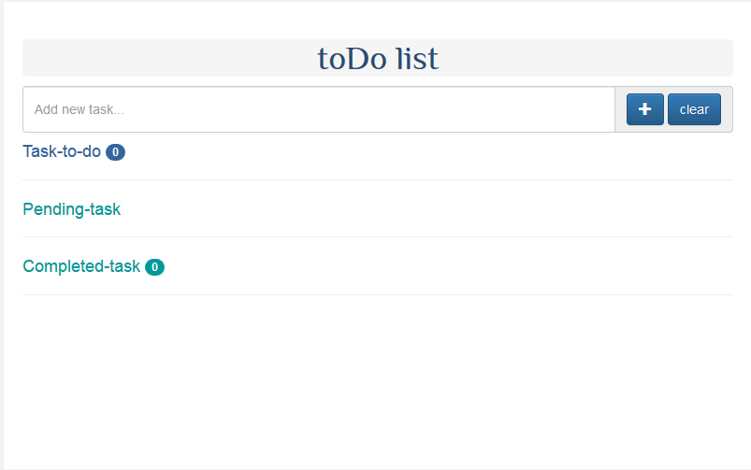

1. With Newly **Added** Task .

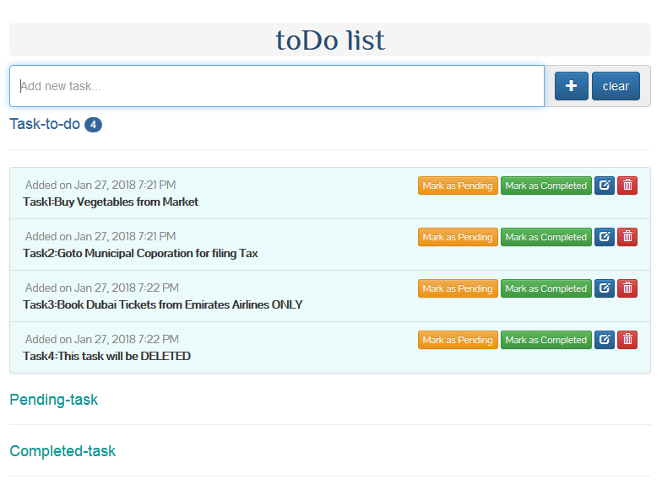

1. With Task marked as **PENDING**

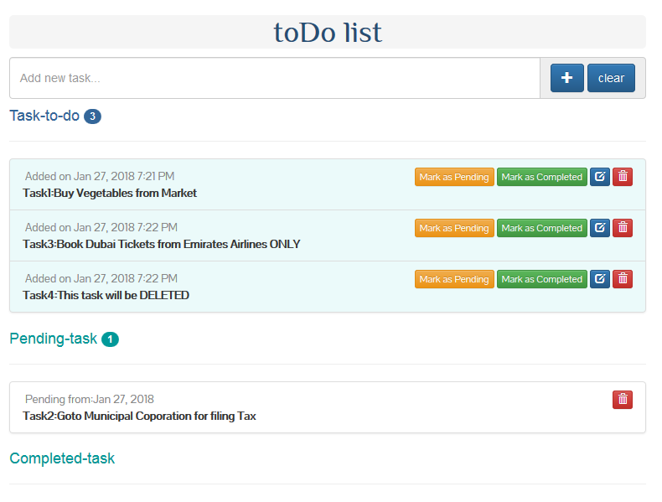

1. With Task marked as **COMPLETED**

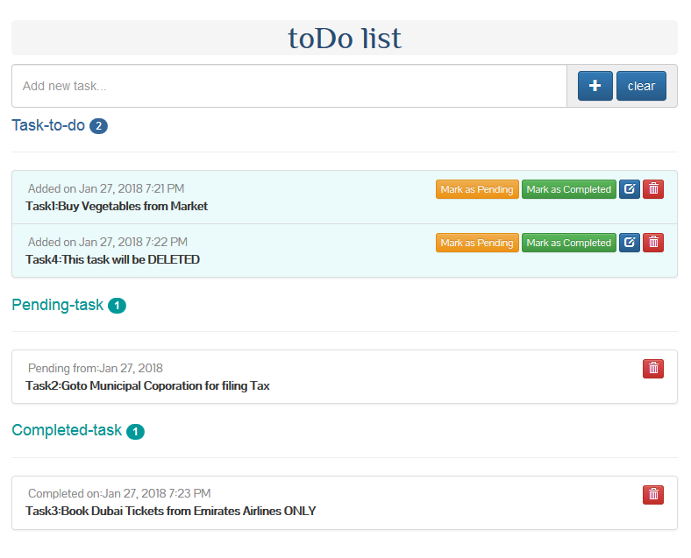

1. After Task **DELETE**.

